Approve a DQA Physics Report in MOSAIQ

# Purpose

After Kaley performs DQA, she generates a report from the Delta4 software and uploads it to the patient’s chart in MOSAIQ. (See Delta4 for DQA and Upload DQA Physics Report to MOSAIQ.) This document is of type **P- Physics Report**. Kaley sets the document reviewer to the “main” (typically onsite) physicist for the day and sets the status to **Review Required** so that the document shows up for the physicist to approve. The physics report should be approved before treatment begins.

# Steps

1. In MOSAIQ, go to your **Documents** Work List. All documents requesting your review have status **My Review Required**.

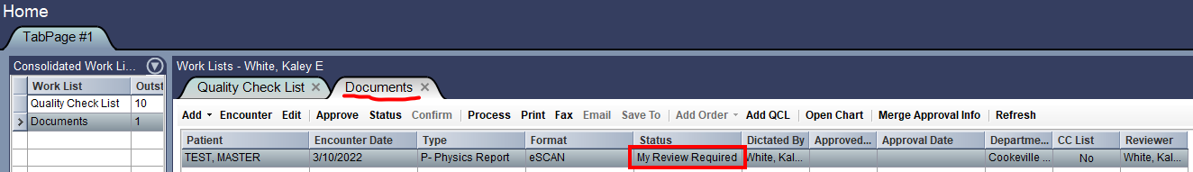

1. View the document by either:
   * Double-clicking it to open it in the **Documents** Work List Detail.

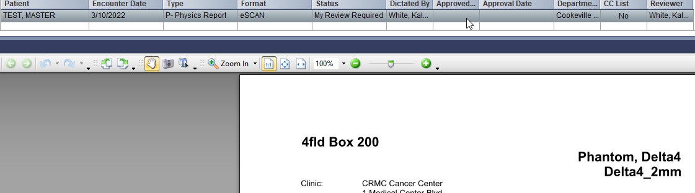

**Note:** If the **Documents** Work List Detail is not part of your Workspace, double-clicking the document will open the **Document Scan** window (the window in which eSCAN documents are uploaded).

* + Opening the **Documents** window and double-clicking the document. If the patient’s chart is open, the **Documents** window will by default show only their documents. You can open the patient’s chart from the **Documents** Work List by clicking **Open Chart** while the document is highlighted.

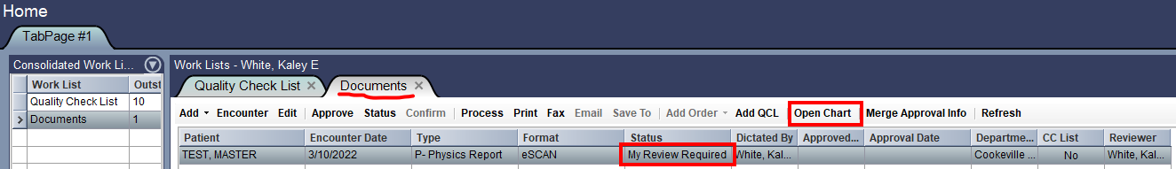

1. With the document highlighted, either:
   * Right-click it and select **Status**.

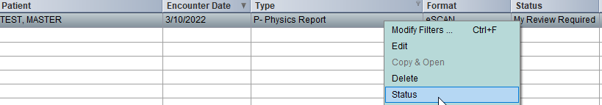

* + Select **Status** at the top.



1. Change the status from **Review Required** to **Approved**, and enter your password.

